Incorporating Basic Food Storage in a Provident Living Plan
San Clemente Stake Plan for 2011-2012
Class #3
“Planting Tomatoes from Seed”

I have invited a special guest, Quinn Bork, who is a horticulturist from “Shore Gardens Nursery” here in San Clemente.
Quinn will be teaching us how evaluate our individual growing sites for tomatoes, how to select the proper variety to maximize that site and produce the most tomatoes possible for the given area (whether you have a nice big garden, or a confined patio container).
He has brought a variety of tomato seeds, planting containers, potting mix and marker sticks for you to use today.
At the end of this class, you will go home with two tomato containers planted with the seeds of your choice. You will learn how to nurture them to approximately 4 to 6 inch sturdy plants and in our follow up class on March 3rd, you’ll learn how to transplant them into their final growing locations and how to care for them through to a prolific harvest.
Once we reach harvest time, we will have the third “tomato” class on how to can, dehydrate, freeze and cook with your wonderful tomatoes. (If you haven’t eaten every last one fresh from the vine!)
Quinn is available at:
Shore Garden Nursery,
201 South Ola Vista San Clemente, CA 92672-4194
(949) 492-3526
qbplantman@yahoo.com

Tomato Facts
The word “tomato” is derived from the Nahuatl (Aztec language) word, tomatl, meaning “something round and plump.” Over the years, the tomato has endured many names including “love apple,” “golden apple,” “apple of paradise” and even “devil apple” by those who believed the tomato to be poisonous.
Tomato, a nutritious fruit commonly used as vegetable, is another wonderful gift of Mayans and Aztecs. This vegetable has grabbed the attention of millions of health seekers for its incredible phyto-chemical properties. Interestingly, it has much more health benefiting qualities than that in an apple!
Botanically, the vegetable belongs to Solanaceae or nightshade family, which also includes chili peppers, potato, eggplant...etc and named scientifically as Lycopersicon esculentum. This exotic vegetable of all seasons is native to central America and was cultivated by the Aztecs centuries before the Spanish explorers introduced it to all over the world.
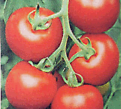 | 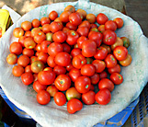
Tomatoes- Red skin variety. | Fresh produce in a market.

Reasons to Eat Tomatoes
One serving of tomatoes provides:
- An excellent source of Vitamins A and C.
- A source of potassium, Vitamin B6 and thiamin.
- Rich in lycopene, the carotenoid responsible for the red color in tomatoes and other red fruits and vegetables. Lycopene is a powerful antioxidant that decreases the risk of certain cancers and heart disease.
A serving of tomatoes is about one cup chopped tomato. This is a big serving for a child.
Introduce smaller amounts, like one half cup, to help children reach their total daily needs.
Cooked tomato products, sauces and juices contain higher amounts of lycopene than raw tomatoes due to greater concentration.
Health benefits of Tomato
Tomatoes are one of the low calorie vegetables containing just 18 calories per 100 g. They are also very low in any fat content and have zero cholesterol levels. Nonetheless, they are excellent sources of antioxidants, dietary fiber, minerals, and vitamins. Because of their all-round qualities, dieticians and nutritionists often recommend them to be included in cholesterol controlling and weight reduction programs.
The antioxidants present in tomatoes are scientifically found to be protective against cancers including colon, prostate, breast, endometrial, lung, and pancreatic tumors.
Lycopene, a flavonoid antioxidant, is the unique phytochemical present in the tomatoes. Red varieties are especially concentrated in this antioxidant. Together with carotenoids, it has the ability to protect cells and other structures in the body from harmful oxygen free radicals. Studies have shown that lycopene prevents skin damage from ultra-violet (UV) rays and offers protection from skin cancer.
Zeaxanthin is another flavonoid compuond present abundantly in this vegetable. Zeaxanthin helps protect eyes from "age related macular disease" (ARMD) in the elderly persons by filtering harmful ultra-violet rays.
- The vegetable contains very good levels of vitamin A, and flavonoid anti-oxidants such as α and ß-carotenes, xanthins and lutein. Altogether, these pigment compounds are found to have antioxidant properties and are take part in vision, maintain healthy mucus membranes and skin, and bone health. Consumption of natural vegetables and fruits rich in flavonoids is known to help protect from lung and oral cavity cancers.
- In addition, they are also good source of antioxidant vitamin-C (provide 21% of recommended daily levels per 100 g); consumption of foods rich in vitamin C helps body develop resistance against infectious agents and scavenge harmful free radicals.
- Fresh tomato is very rich in potassium. 100 g contain 237 mg of potassium and just 5 mg of sodium. Potassium is an important component of cell and body fluids that helps controlling heart rate and blood pressure caused by sodium.
- They contain moderate amounts of many vital B-complex vitamins such as folates, thiamin, niacin, riboflavin as well some essential minerals like iron, calcium, manganese and other trace elements.
See the table below for in depth analysis of nutrients:
Tomato (Lycopersicon esculentum), raw,
Nutrition value per 100 g.
(Source: USDA National Nutrient data base)
Principle | Nutrient Value | Percentage of RDA
Energy | 18 Kcal | 1%
Carbohydrates | 3.9 g | 3%
Protein | 0.9 g | 1.6%
Total Fat | 0.2 g | 0.7%
Cholesterol | 0 mg | 0%
Dietary Fiber | 1.2 g | 3%
Vitamins
Folates | 15 µg | 4%
Niacin | 0.594 mg | 4%
Pyridoxine | 0.080 mg | 6%
Thiamin | 0.037 mg | 3%
Vitamin A | 833 IU | 28%
Vitamin C | 13 mg | 21.5%
Vitamin E | 0.54 mg | 4%
Vitamin K | 7.9 µg | 6.5%
Electrolytes
Sodium | 5 mg | >1%
Potassium | 237 mg | 5%
Minerals
Calcium | 10 mg | 1%
Iron | 0.3 mg | 4%
Magnesium | 11 mg | 3%
Manganese | 0.15 mg | 6.5%
Phosphorus | 24 mg | 3%
Zinc | 0.17 mg | 1.5%
Phyto-nutrients
Carotene-ß | 449 µg | --
Carotene-α | 101 µg | --
Lutein-zeaxanthin | 123 µg | --
Lycopene | 2573 µg | --

Varieties of Tomatoes

Varieties are commonly divided into these categories, based mostly on shape, use and size (small to large):
- Cherry: sweet tomatoes, usually eaten whole in salads
- Plum: pear-shaped, more meaty, ideal for tomato sauces also called Italian or Roman
- Slicing: round or globe-shaped, used mainly for common table servings
- Beefsteak: round, juicy, used mainly for sandwiches
- Other varieties include heirlooms and yellow/orange tomatoes. Sweeter than most red or green, yellow/orange tomatoes contain more Vitamin C and potassium, but no lycopene

What is the difference between "determinate" and "indeterminate" tomato plants?
Determinate varieties of tomatoes, also called "bush" tomatoes, are varieties that are bred to grow to a compact height (approx. 4 feet).
They stop growing when fruit sets on the terminal or top bud, ripen all their crop at or near the same time (usually over a 2 week period), and then die.
They may require a limited amount of caging and/or staking for support, should NOT be pruned or "suckered" as it severely reduces the crop, and will perform relatively well in a container (minimum size of 5-6 gallon). Examples are: Rutgers, Roma, Celebrity (called a semi-determinate by some), and Marglobe.
Indeterminate varieties of tomatoes are also called "vining" tomatoes. They will grow and produce fruit until killed by frost and can reach heights of up to 10 feet although 6 feet is considered the norm. They will bloom, set new fruit and ripen fruit all at the same time throughout the growing season.
They require substantial caging and/or staking for support and pruning and the removal of suckers is practiced by many but is not mandatory. The need for it and advisability of doing it varies from region to region. Experiment and see which works best for you. Because of the need for substantial support and the size of the plants, indeterminate varieties are not usually recommended as container plants. Examples are: Big Boy, Beef Master, most "cherry" types, Early Girl, most heirloom varieties, etc.

Why grow your own tomatoes?

If you have ever tasted a fresh tomato, warmed from the sun and just plucked from the vine, then you have your answer to this question. If you haven’t had this experience you MUST grow your own tomatoes so you know what they REALLY taste like.
Supermarket tomatoes have generally been away from a connected vine for some time before reaching you from the supermarkets. Many vitamins would have degraded in that time, and those fresh from a living plant will contain vastly more nutritional richness, if you eat them quickly and without cooking them. Most supermarket tomatoes are grown with chemical additives and with the use of pesticides which you can control (NOT USE) in your own gardens.
In most cases it is less expensive to grow your own vegetables (it can be a little costly to get started) but tools, containers and cages can be reused from year to year. You will need to invest some money, time and “love” into your tomato plants, but they will reward you with the most tasty and most nutritious tomato you’ll ever have.
Another advantage is that you’ll know that these are truly organic and pesticide free because you’ll be in charge of your own tomatoes! You can pick them at peek ripeness for best flavors and nutrient values.
Caring for your garden, nurturing your own plants is a great stress-reliever and is a wonderful family project. Involve your children at all levels. There are ever so many lessons to be taught around this exercise.
Homegrown tomatoes, eaten straight from the vine are still warm and still processing the sugars they have formed in the sun. Chilling tomatoes as is often done in the logistics chain for a supermarket destroys some of those sugars and other flavor-some compounds making tomatoes much less tasty and less nutritious than freshly picked fruit.
In my opinion, it’s healthier for our bodies and our spirits to be involved at a much closer level to our own food production. We may someday be deprived of the super markets and may need to know how to be more self reliant in our food production, but for today, the main reason to grow your own tomatoes is because you can’t buy a tomato that tastes like a freshly picked home grown tomato! (this is the mantra for this class!)
NO VEGETABLE IS MORE COMMONLY GROWN by home gardeners than the tomato .
However, tomatoes grown at home are not something for someone with little or no time. Expect to invest time in choosing soil mixes, sorting out seeds, finding places to plant them, ensuring they are tended with sun, water, food and pruning so they produce tomatoes and not just leaves or stem. You need to inspect them daily to watch for signs of disease or pests and while you are at it, talk or sing to them….they’ll love you for it!
If you get some really great seeds, and you do a lot of things right with soil mixing, and use compost sourced from your own kitchen, then you may be able to grow tasty and cheap tomatoes.
However, if you buy seeds and fertilizer, buy pots, canes to hold up tomatoes, trellises for them to grown on, other gardening tools, as well as methods to deal with pest problems, then tomatoes can soon become more expensive than any supermarket variety. Without getting it right, your labor could result in only 3 or 4 tomatoes a week in the peak season - which would be disappointing. Training and experience will improve that though. And oh my, when you do get it right, though, the rewards are priceless!
Hopefully these few tips will give you an idea about the reality of growing your own tomatoes.

How Do Tomatoes Grow?
Generally, the time to start your seeds is about 6- 8 weeks before the last expected spring frost date in your area, planting the seedlings outdoors about 2 weeks after that date. Another way to figure is to plan on setting out sturdy seedlings in the garden when night temperatures stay in the mid-50 degree range both day and night. Count back and sow seeds 6 to 8 weeks before that date normally arrives.
We’ll learn to transplant our plants into their permanent growing locations and how to care for them through harvest at the next class on March 3rd, at 9:30 AM.

1  Starting indoors, in a container of well moistened, sterile seed-starting mix, make shallow furrows with a pencil or chopstick about 1/4 in. deep. Sow seeds by dropping them along the bottom of the furrows 1/2 in. apart. | 2  Gently pinch together soil to cover each furrow, covering seeds 1/4 in. deep. Water gently and label each variety. Put container in a warm place, 75-80˚ F. As soon as seed begin germinating and stems start to show above the soil, it's critical to provide a strong light source such as florescent bulbs or a very sunny window.
3  Day 7 - Seedlings have germinated. First to appear are "baby" or "cotyledon" leaves. Careful labeling of each variety is important as they all look alike. | 4  Day 15 - Seedlings are still tiny with just baby cotyledon leaves, but growing well. Note the nice green color of the baby leaves. This indicates that plants are getting enough bright light to thrive.
5  Day 30 - The first set of "true" tomato leaves begin to appear above the baby cotyledon leaves. The best example of this is in front of the pencil eraser in this picture. | 6  (This is the size we’ll start our seeds in) Tomato seedlings will readily grow new roots along their buried stems and the resulting plants will be sturdy and vigorous. Gently water in the seedlings to settle the plants.
7  Here are examples of what healthy and cold stressed seedling look like. Remember that seedlings need to be kept at about 65 - 70 degrees after they have true leaves and until they are ready to go into the garden. They need 12 to 16 hours of sunlight or artificial light to grow into sturdy plants. | 8  When spring weather has warmed up and night temperatures are regularly in the 55 degree range, it's time to plant well rooted, established seedlings outdoors. First plan to acclimate your plants: move them outside into the sun, first for a few hours , then gradually increasing over a weeks' time until they are in full sun all day. this process is called "hardening off" and it avoids transplant shock.
9  At transplanting time, if hardened off young plants are more than 6 in. tall, remove the bottom branches before planting. New roots will form along the buried stem. | 10  Prepare the hole to receive the seedling. It’s good to know the composition of the soil and the proper additives to help your plants grow strong and productive. (Quinn will give us a recipe for proper tomato nutrients.)
11  Tip out plant by overturning pot to squeeze or tap out the entire root ball. Note the snipped off lower branches on this example ready to go into the ground. | 12  Settle the seedling into the hole, so the entire stem will be covered up to where leafy branches begin. Pull soil around the plant and firm.
13  Water gently but thoroughly and erect your tomato supports. Be sure they are well secured, because your plants will grow large and heavy with fruit, so you will need strong support for the branches. | 14  Make certain that if you are growing in a container, you water thoroughly once a week and be certain also that the container drains properly. Check frequently to be certain your tomato gets enough water, but remember over watering can cause disease and loss of fruit.
15  Enjoy the harvest! For heirloom varieties like our Rainbow's End, it's best to wait for full ripeness before picking the luscious, color fruit. | 16  Slicers, like Crimson Carmello or  Chianti Rose can be harvested at any stage you like them.
17  Don't forget your sauce tomatoes. Here's a bowl of variety Pompeii all ready to put up. I like to freeze them whole, then make sauce later when the weather is cooler, and making big pots of tomato sauce is fragrant fun. | 18  Heirloom Camp Joy cherry tomatoes are very prolific and delicious.

What ‘deep’ means (to a tomato)

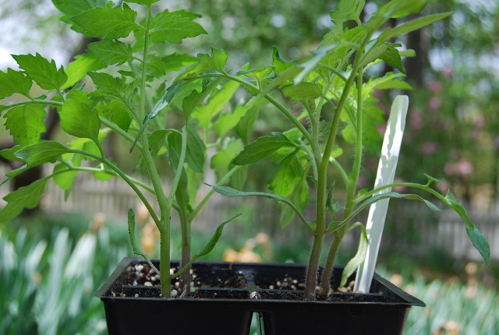
When I say “deep” I’m talking tomatoes, and how to plant them. Whether you are planting in the ground or in a pot, tomatoes will produce best if they are well-rooted, so bury them deep, right down to the topmost pair or two of leaves. They are able to root all along their stems if you plant them very deep or even sideways, in a trench. The latter goes like this: Dig a small trench about 6 to 8 inches deep and almost as long as the plant (including its rootball) is tall. Lay the plant horizontally in the trench, gently bending the top end upward, and bury all but that end with the upper pair or two of leaves.
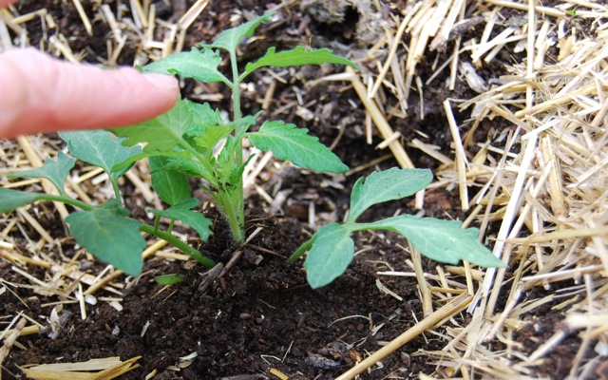
Staked or trellised tomatoes take up less space than caged ones, but require regular tying up and pruning of excess foliage. I used to cage mine in a collection of wire cages, the best of which I made from concrete reinforcing wire of a large, rectangular gauge. The cages should be 18-24 inches across, and even at that size the biggest growers will push out quickly, anyhow. If you have already purchased the pitifully undersized tomato cages from the garden center, don’t despair, use them for your peppers.

