Incorporating Basic Food Storage in a Provident Living Plan
San Clemente Stake Plan for 2011-2012
Class #9
“Preserving Tomatoes, Canning, Freezing & Dehydrating”

Canning & Preserving
Canning Basics for Preserving Food

History of Food Processing
Canning and preserving food has a history dating back to 1795 when Napoleon, knowing that his army marched on its stomach, offered 12,000 francs to anyone who could devise a way to preserve food for his army and navy. 14 years later, Nicolas Appert of France, won the prize money by devising a way to put food in jars and seal them. He found that they would stay relatively fresh until they were opened.
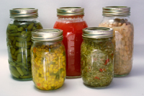A year later, Peter Durand of England got a patent using pottery, glass and tin plated iron to be used in canning.
Americans arrived on the scene in 1812, when a small plant in New York used hermetically sealed containers for oyster, meats, fruits and vegetables. Now the rush was on. From 1818, when the tin plated can was introduced in America, to 1838 with the invention of the can opener, to the present day…. canning and preserving has been on the move.
However, one of the major problems that kept showing up in canning foods was the problem of spoiling. Louis Pasteur, the father of germ theory and bacteriology, figured out that it was microorganisms that were spoiling the food. If the bacteria entered the body, it would cause Botulism, a serious disease that causes flaccid paralysis of muscles. (sagging paralysis of muscles.) Botulism can still be a problem if you ingest food that is not proper canned or has been allowed to spoil.
It is important that your bottles, lids and canning equipment are sterilized and that your food is sealed properly.
Canning and preserving food can safe and rewarding. Canned goods can last several years, but it’s best to use your preserved food with in a year.
What does canning do?
Canning is an important, safe method for preserving food if practiced properly. The canning process involves placing foods in jars or similar containers and heating them to a temperature that destroys micro-organisms that cause food to spoil. During this heating process air is driven out of the jar and as it cools a vacuum seal is formed. This vacuum seal prevents air from getting back into the product bringing with it contaminating micro-organisms.
Safe Canning Methods
There are two safe ways of canning food, the boiling water bath method and the pressure canner method:
- The boiling water bath method is safe for tomatoes, fruits, jams, jellies, pickles and other preserves. In this method, jars of food are heated completely covered with boiling water (212°F at sea level) and cooked for a specified amount of time
- Pressure canning is the only safe method of preserving non-acid foods like vegetables, meats, poultry and seafood. Jars of food are placed in 2 to 3 inches of water in a special pressure cooker which is heated to a temperature of at least 240° F. This temperature can only be reached using the pressure method. A microorganism called Clostridium botulinum is the main reason why pressure processing is necessary. Though the bacterial cells are killed at boiling temperatures, they can form spores that can withstand these temperatures. The spores grow well in low acid foods, in the absence of air, such as in foods like meats and vegetables. When the spores begin to grow, they produce the deadly botulinum toxins (poisons).

The only way to destroy these spores is by pressure cooking the food at a temperature of 240°F, or above, for a specified amount of time depending on the type of food and altitude. Foods that are low acid have a pH of more than 4.6 and because of the danger of botulism, they must be prepared in a pressure canner.
The low acidic foods include:
- meats
- seafood
- poultry
- dairy products
- all vegetables
High acid foods have a pH of 4.6 or less and contain enough acid so that the Clostridium botulinus spores can not grow and produce their deadly toxin. High acidic foods can be safely canned using the boiling water bath method.
The high acidic foods include:
- fruits
- properly pickled vegetables
Certain foods like, tomatoes and figs, that have a pH value close to 4.6 need to have acid added to them in order to use the water bath method. This is accomplished by adding lemon juice of citric acid.
Canning Equipment
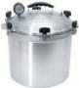
Water Bath Canners
A water bath canner is a large cooking pot, with a tight fitting lid and a wire or wooden rack that keeps jars from touching each other. The rack allows the boiling water to flow around and underneath jars for a more even processing of the contents. The rack also keeps jars from bumping each other and cracking or breaking. If a rack is not available, clean cotton dish towels or similar can be used to pack around jars. If a standard canner is not available any large metal container may be used as long as it is deep enough for l to 2 inches of briskly boiling water to cover the jars. The diameter of the canner should be no more than 4 inches wider than the diameter of your stove's burner to ensure proper heating of all jars. Using a wash kettle that fits over two burners is not recommended because the middle jars do not get enough heat. For an electric range, the canner must have a flat bottom. Outdoor fire pits with a solid grate will also work however close attention is required to insure proper boiling temperature.
Pressure Canners
A pressure canner is a specially-made heavy pot with a lid that can be closed steam-tight. The lid is fitted with a vent (or pet-cock), a dial or weighted pressure gauge and a safety fuse. Newer models have an extra cover-lock as an added precaution. It may or may not have a gasket. The pressure pot also has a rack. Because each type is different, be sure to read the directions for operating.
Jars
Mason jars and Ball jars specifically designed for home canning are best. Commercial mayonnaise jars, baby food and pickle jars should not be used. The mouths of the jars may not be appropriate for the sealing lids and the jars are not made with heavy glass and they are not heat treated.
Jars come in a variety of sizes from half-pint jars to half-gallon jars. Pint and quart Ball jars are the most commonly used sizes and are available in regular and wide-mouth tops. If properly used, jars may be reused indefinitely as long as they are kept in good condition.
Jar Lids
Most canning jars sold today use a two piece self-sealing lid which consists of a flat metal disc with a rubber-type sealing compound around one side near the outer edge, and a separate screw-type metal band. The flat lid may only be used once but the screw band can be used over as long as it is cleaned well and does not begin to rust.
Canning Utensils
Helpful items for home canning and preserving:
- Jar lifter: essential for easy removal of hot jars.
- Jar funnel: helps in pouring and packing of liquid and small food items into canning jars.
- Lid wand: magnetized wand for removing treated jar lids from hot water.
- Clean cloths: handy to have for wiping jar rims, spills and general cleanup.
- Knives: for preparing food.
- Narrow, flat rubber spatula: for removing trapped air bubbles before sealing jars.
- Timer or clock: for accurate food processing time.
- Hot pads
- Cutting board

There are also many specialty utensils available like apple slicers, cutting spoons for coring and pit removal, corn cutters and fruit skinners.
Your best source for current information on research and processing instructions are publications made by the U.S. Food and Agriculture Department, College Cooperative Extension Services and major food processing equipment manufactures.

How to Can Fresh Tomatoes with a Water Bath Canner!
Making canned tomatoes is something families remember years later. Home-canned tomatoes have been a tradition for many generations. In the middle of the winter, you can use the tomatoes to make a fresh spaghetti sauce, lasagna, chili, or other tomato-based meals for that fresh garden taste.
Here's how to do it, in easy steps and completely illustrated. This method is so easy, ANYONE can do this! It's a great thing to do with your kids! Also, this recipe/directions works with either red (ripe) or green (unripe tomatoes).
Ingredients and Equipment
- Tomatoes - about 20 lbs to make 7 quarts (7 large tomatoes will fill one quart jar.)  - lemon juice - fresh or bottled, about 1/2 cup  - 1 Water bath Canner (a huge pot to sanitize the jars after filling (about $30 to $35 - $30 at mall kitchen stores and local "big box" stores. Tomatoes are on the border between the high-acid fruits that can be preserved in a boiling-water bath and the low-acid fruits, vegetables and meats that need pressure canning  - 1 large pot (to scald the tomatoes, step 3) and 1 small pot to sanitize the lids. | - Pint or quart canning jars (Ball or Kerr jars can be found at most grocery stores - about $13 per dozen quart jars including the lids and rings).  - Lids - thin, flat, round metal lids with a gum binder that seals them against the top of the jar. They may only be used once.  - Rings - metal bands that secure the lids to the jars. They may be reused many times.  - Jar grabber (to pick up the hot jars)  - Large spoons and ladles

Process - How to Make Home Canned Tomatoes from Fresh Tomatoes

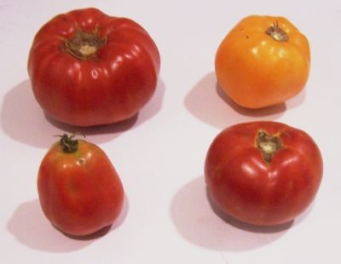
Step 1 - Selecting the tomatoes
It's fun to go pick your own and you can obviously get better quality tomatoes!
At right is a picture of tomatoes from a home garden - they are so much better than anything from the grocery store. And if you don't have enough, a pick-your-own farm is the pace to go! At right are 4 common varieties that will work:
Top left: Beefsteak | Top right: Lemon Boy, yellow
Bottom left: Roma, paste-type | Bottom right: Better Boy
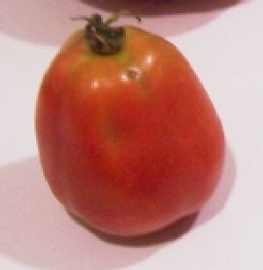
The picture at right shows the best variety of tomato to use for sauce: Roma; also called paste tomatoes. They have fewer sides, thicker, meatier walls, and less water. And that means thicker sauce in less cooking time! You may can cherry tomatoes, grape tomatoes, etc., but they do tend to be more watery, and you must be sure to added the lemon juice as recommended in the recipe, because they tend to be lower in natural acidity.
Also, you don't want mushy, bruised or rotten tomatoes! Canning does not improve bad fruit and just makes all the rest of your produce go bad!!
And for those of you with an abundance of green tomatoes, the USDA says that since green tomatoes are more acidic than ripened fruit, they can be canned safely with any of the standard tomato directions. I prefer to store them in a cool place, where they slowly ripen, but if you have a use later for canned green tomatoes, go for it.

Step 2 - Get the jars and lids sanitizing

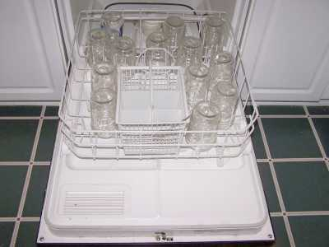
The dishwasher is fine for the jars; especially if it has a "sanitize" cycle. I get that going while I'm preparing everything else, so it's done by the time I'm ready to fill the jars. If you don't have a dishwasher, submerge the jars in a large pot (the canner itself) of water and bring it to a boil.
Be sure to let it go through the rinse cycle (or two) to get rid of any soap!

Get the canner heating up
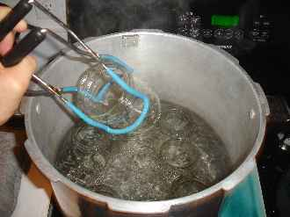
Fill the canner about 1/2 full of water and start it heating (with the lid on).

Start the water for the lids

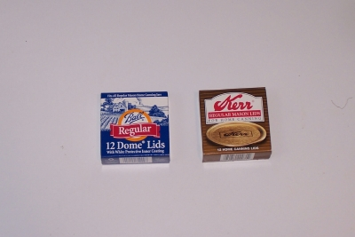
Put the lids into the small pot of boiling water for at least several minutes. Note: everything gets sanitized in the water bath (step 7) anyway, so this just helps to ensure there is no spoilage later!)
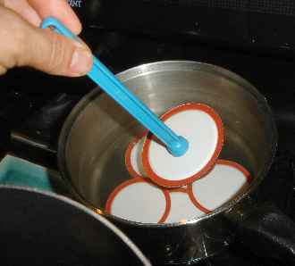

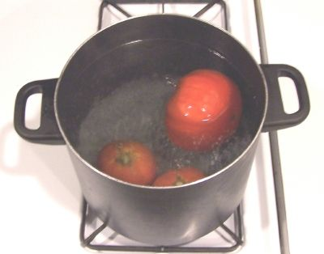
Step 3 - Removing the tomato skins
Here's a trick you may not know: cut an X in the bottom of the tomatoes and put the tomatoes, a few at a time in a large pot of boiling water for no more than 1 minute (30 - 45 seconds is usually enough)

then....

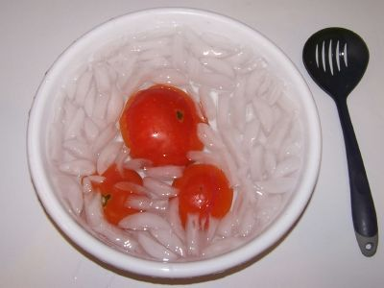
Plunge them into a waiting bowl of ice water.
This makes the skins slide right off of the tomatoes! If you leave the skins on, they become tough and chewy and not very pleasant.

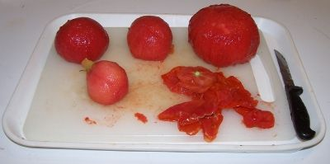
Step 4 - Removing the skins, bruises and tough parts
The skins should practically slide off the tomatoes. Then, you can cut the tomatoes in quarters and remove the tough part around the stem and any bruised or soft parts.

Step 5 - Fill the jars with the whole or cut tomatoes
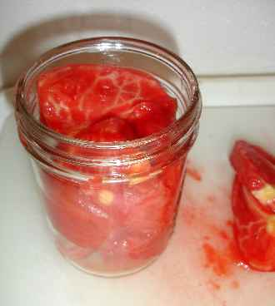
Fill them to within ¼-inch of the top with tomatoes

Step 6 - Add 2 Tablespoons of lemon juice and liquid
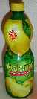
After you fill each jar with tomatoes, add 2 tablespoons of lemon juice per quart jar, 1 per pint jar. This helps to reduce the odds of spoilage and to retain color and flavor. Add 1 full teaspoon of salt to each quart of tomatoes.

Step 7 - Free any trapped air bubbles
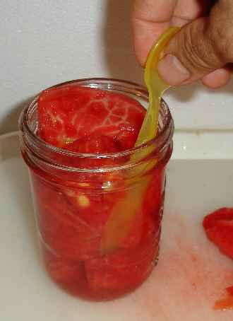
Using a flat plastic or wood utensil (like a plastic spoon, up side down) free trapped air bubbles by gently sliding it up and down around the inside edge.
Before you put the lids on be sure the contact surfaces (top of the jar and underside of the ring) are VERY clean to get a good seal.

Step 8 - Put the lids and rings on
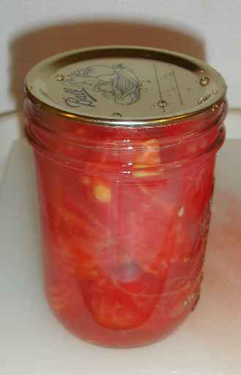
Just screw them on snugly, not too tight. If the is any tomato on the surface of the lip of the jar, wipe it off first with a clean dry cloth or paper towel.

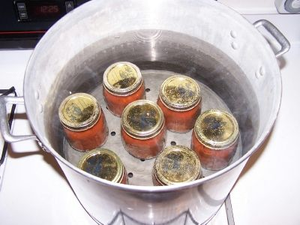
Step 9 - Boil the jars in the water bath canner
Put them in the canner and keep them covered with at least 1 inch of water. Keep the water boiling. Process the jars in a boiling-water bath for 40 minutes for pints and 45 minutes for quarts. Remember to adjust the time if you are at a different altitude other than sea level!
Recommended process time for Crushed Tomatoes in a boiling-water canner.
 |  | Process Time at Altitudes of
Style of Pack | Jar Size | 0 - 1,000 ft | 1,001 - 3,000 ft | 3,001 - 6,000 ft | Above 6,000 ft
Hot | Pints | 35 min | 40 | 45 | 50
 | Quarts | 45 | 50 | 55 | 60

Step 10 - Done
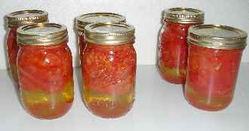
Lift the jars out of the water and let them cool in a draft-free place without touching or bumping them (usually takes overnight) The most fun is listening for your jars to “pop”…when they seal the lid is vacuumed down and makes a “popping” sound. Once the jars are cool, you can check that they are sealed verifying that the lid has been sucked down. Just press in the center, gently, with your finger. If it pops up and down (often making a popping sound), it is not sealed. If you put the jar in the refrigerator right away, you can still use it. Some people replace the lid and reprocess the jar, then that's a bit iffy. If you heat the contents back up, re-jar them (with a new lid) and the full time in the canner, it's usually ok. Don't worry if you see the tomatoes floating above a layer of liquid; that's normal. tomatoes have a lot of water in them and it separates a bit. If I had packed the tomatoes in the jars a bit tighter or squeezed some of the free liquid out of them before packing them in the jars, the water layer would be reduced. When the jars are completely cool, you can then remove the rings if you like, but if you leave them on, at least loosen them quite a bit, so they don't rust in place due to trapped moisture. Before storing the jars, wash them off and dry them. Store jars in a cool darkened area of your home.

How to Freeze Tomatoes From Your Garden
Freezing home grown or farm fresh tomatoes for use in winter cooking is very easy to do! The flavor of spaghetti sauce, lasagna, and salsas you make then will be superior to those made from canned tomatoes or store bought so called "fresh" tomatoes.
Here's how to do it, in easy steps and completely illustrated. This method is so easy, ANYONE can do this! It's a great thing to do with your kids!

Ingredients and Equipment
- Tomatoes - any quantity, ripe, but not over ripe, still firm.  - Vacuum food sealer or plastic freezer bags | - 1 large pot  - Large slotted spoon

Step 1 - Selecting fully ripened tomatoes

Step 2 - Remove the tomato skins (or remove later when adding to stews or sauces)

Step 3 -Removing bruises and tough parts

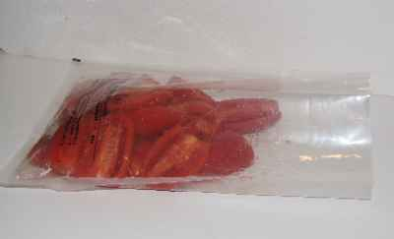
Step 6 - Fill the freezer bags
Don't overfill the bags, leave a little room for expansion. Do try to avoid leaving any air pockets! A vacuum bag is shown at left, but you can use ziploc (or similar) bags, show below. But be sure to squeeze out the extra air (above is before, below is after squeezing out the excess air)

Step 7 - Vacuum seal the bags (if you have a vacuum sealer)
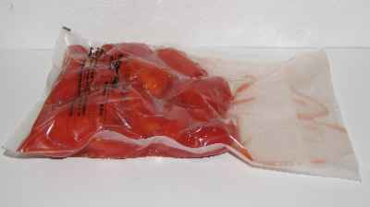
Obviously if you haven't got a vacuum food sealer, just inspect the bags and you may need to open them and reseal them to eliminate any air pockets!
TIP: If you don't own a vacuum food sealer to freeze foods, place food in a Ziploc bags, zip the top shut but leave enough space to insert the tip of a soda straw. When straw is in place, remove air by sucking the air out. To remove straw, press straw closed where inserted and finish pressing the bag closed as you remove straw.

Step 8 - Freeze the bags
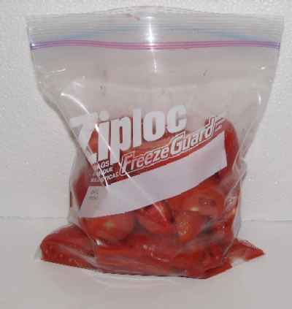
Pop them into the freezer (on the quick freeze shelf, if you have one). Now leave them for 2 or 3 hours till frozen.
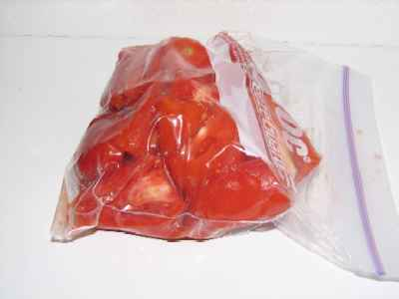

Put in the back (coldest part) of your freezer
And wait for a cold winter night when it is dark and dreary out, to remove it and defrost (microwave works well) and use in making so fresh tasting spaghetti sauce or other tomato cooking! If you partially thaw them you can cut them up for your salads…they are much better than the hot-house “tomatoes” you find in the supermarket.

How to dehydrate tomatoes

How Food Dehydrators Work for Drying Tomatoes
A food dehydrator is a device used to dry foods. They range in price from approximately $30 to $40 up to $200+. If you only use them occasionally for your garden produce, the inexpensive models work just fine and are available at most Target or Walmart stores or on-line.
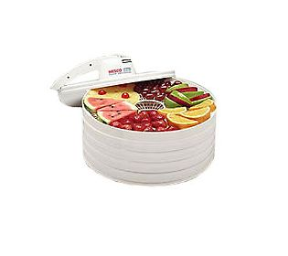All dehydrators operate on the same principle: they remove water from food.
Getting the moisture out helps with storage. It lowers the weight of food and lets it take up less space. Even better, dehydrating preserves foods. Bacteria, fungi, molds, and other microorganisms need water to grow. By removing moisture, you inhibit them. Drying creates a firm exterior shell which works further to keep microorganisms out of preserved food.
A tomato is more than 90% water. Since dehydrating tomatoes enhances storage and preserving, you can see why it can have big advantages in preserving tomatoes.

Dehydrator designs:
Dehydrator designs are classified by two elements: by how they dry tomatoes and how trays are arranged.

Dehydrator designs categorized by how they dry tomatoes
Tomatoes are dried by fans blowing the heated air across the fruit

Dehydrator designs categorized by trays
Another way home-food dehydrators are categorized is by their trays. Some models are designed with stackable trays. Others are constructed as a box with removable shelves.
Stackable trays. One advantage of stackable trays is flexibility: you can re-size your dehydrator to fit your needs. If you dry smaller amounts of food, buy fewer trays. If you need more tray space, expand your dehydrator with more trays. But stackable trays come with a caveat. Most dehydrators with stackable trays have vertical air movement, since heating and ventilation elements must be placed at the top or bottom of the unit in order to allow you to add and subtract trays as needed. Tomatoes on the trays closest to the heat element and fan dry much faster than those at the top of the stack. Heat is unevenly distributed. As tomatoes dry, you must be careful to rotate trays.
Removable shelves. Box-style dehydrators with removable shelves usually have the fan in the rear (horizontal air movement). Tomatoes dry evenly. These units are a fixed size.

Advantages to dehydrating tomatoes in a dehydrator
- Dehydrators produce the best quality dried food of any drying method
- Dehydrators don’t need sunny weather
- Dehydrators allow you to control temperature and air circulation so tomatoes dry evenly.
- Dehydrators don’t heat up your kitchen; they can be operated on a porch, garage, or anywhere there’s an electric source

Disadvantages to dehydrating tomatoes
- You must purchase a dehydrator (but you can use for year after year)
- Using a dehydrator can take up to 8-12 hours per batch of tomatoes
Use tomatoes of uniform size for most even results.
- Set the dehydrator temperature at 135º-140ºF. (If your dehydrator doesn’t have a thermostat, set a cooking thermometer in the bottom tray.)
- Wash and dry tomatoes.
- Remove skins (optional). With a knife, cut an X on the bottom of the tomato, just deep enough to penetrate the skin. Drop tomato into boiling water. Blanch for 20-30 seconds. Use a slotted spoon to remove tomato from boiling water. Immerse tomato in ice water. Use knife to remove tomato core. Skin will slip off.
- Core tomatoes (whether skinned or not). Remove tomato ends.
- Cut tomatoes.
Roma tomatoes: cut in halves or quarters
Cherry tomatoes: cut in half
Slicing tomatoes: cut into 3/8” slices
- Place tomatoes cut-side up on dehydrator trays, about ½” apart. Do not allow tomatoes to touch. Sprinkle tomatoes with salt, garlic powder, or fresh herbs (as desired).
- Allow 1-2” between each dehydrator rack for good air circulation.
- Dry tomatoes. Check them regularly. If necessary, rotate racks to allow tomatoes to dry evenly. Remove pieces that dry before others to prevent them from scorching. Average dry time in a dehydrator is 8-12 hours.
- Dried tomatoes will be reduced in size, shriveled and leathery, but not tacky. Remove tomatoes from the dehydrator and allow them to cool thoroughly.
- Pack tightly in freezer bags, vacuum sealed bags, plastic containers, or jars. I like to freeze them once they are dehydrated to keep the flavor longer.

Special tip
It may be tempting to place cherry tomatoes whole in your dehydrator. But if you take the time to slice them in half, you will be able to monitor how well they dry. Otherwise, you’ll have to guess if their interiors are still moist or if they are ready to be removed from the dehydrator.

How to Rehydrate Dried Tomatoes and Oven Dried Tomatoes to Use in Recipes
Dehydrated tomatoes make a great snack without rehydrating them or they can be broken and added to salads for a tasty tomato flavor.
Dried tomatoes can also be rehydrated or reconstituted before they being used in cooking.
There are different reconstituting methods you can choose.

Ways to rehydrate or reconstitute tomatoes:

Soak tomatoes
- Set tomatoes in a bowl with water, bouillon, or vegetable juice.
- Allow tomatoes to steep until they are soft, about 30-60 minutes.
- Drain tomatoes. (Note: save the liquid to use in soups or other recipes. It contains lots of vitamins!)
- Pat tomatoes dry.
- Use as directed in recipes.
- If you soak tomatoes more than 2 hours, set the bowl in the refrigerator to prevent spoilage.

Add tomatoes directly to recipes
- Stir tomatoes directly into soups or stews.
- Let recipe cook slowly. Liquid in these dishes will rehydrate tomatoes.
- This method works only when tomatoes are added to a recipe with a liquid base (such as soup.)

Reconstitute tomatoes in oil
- Dip tomatoes into white wine vinegar before placing in jar with oil to sharpen flavor, acidify oil, and to discourage bacteria and mold growth. (Dried tomatoes look especially attractive in pretty Italian canning jars .)
- Place tomatoes in a jar or bowl.
- Cover tomatoes with oil (olive oil is preferred). Add garlic and fresh herbs as desired. Seal with a tight-fitting lid and refrigerate.
- Let tomatoes sit for at least 24 hours before using.
- Drain tomatoes before using in recipes. Replace oil to cover unused tomatoes.
- Store opened tomatoes in the refrigerator to prevent spoilage. Tomatoes in oil without added garlic and herbs will keep several weeks in the refrigerator. If you add garlic or herbs, use tomatoes within a week to prevent spoilage. Oil will solidify in the refrigerator but will reliquify quickly at room temperature.
- Reserve oil (now flavored) to use in salad dressing or in sautéed dishes.

